**HTML5 - Full stack and Backend**

Module (HTML5) – 3

**UPADHYAY KULBHUSHAN**

**Q. What are the new tags added in HTML5?**

ANS = HTML5 included a new tag to improve the organization and performance of web pages.

* <**header**>: Indicates the area where a section or document's introduction is contained.
* <**nav**>: Defines a section that contains navigation links, such as menus, lists of links, or site navigation bars.
* <**section**>: The tag <section> designates a stand-alone portion of a document that has its own context or subject information.
* <**article**>: Indicates an independent piece of writing in a document, like a forum post, news article, or blog entry.
* <**aside**>: Defines content which related to the surrounding content, presented as a sidebar on webpages.
* <**command**>: Indicates a command the user can invoke.
* <**footer**>: Indicates the bottom of a section in webpage or site, usually holding contact information, author information, and copyright & other information.
* <**main**>: Identifies the primary information in a document and has to be specific to it.
* [<**audio**](https://www.geeksforgeeks.org/html5-audio/)>: The <audio> tag is used to insert an audio into an HTML webpage.
* [<**video**](https://www.geeksforgeeks.org/html5-video/)>: The <video> tag is used to embed video content in a document, such as a movie clip or other video streams.
* <**output**>: Represents some type of output, such as from a calculation done through scripting.
* Together with an optional caption, the <**figure**> and <**figcaption**> tags can be used to display self-contained information like diagrams, pictures, or short segments of code.
* <**time**>: Indicates a certain period or interval of time. Times and dates can be marked using it.
* <**progress**>: Indicates how a task or process is coming along.
* <**summary**> and <**details**>: These tags combine to build a disclosure widget that lets the user reveal or conceal further details.
* When used with the <input> tag and its list property, <**datalist**> specifies a list of pre-defined choices for an input element.

These are few examples of the HTML5 tags. New input types, form validation properties, support for audio and video, a canvas for graphic sketching, and other enhancements and capabilities were also introduced by HTML5.

**Q. How to embed audio and video in a webpage?**

ANS. With <audio> tag we are embed audio in a webpage or HTML documents (<audio> </audio>).

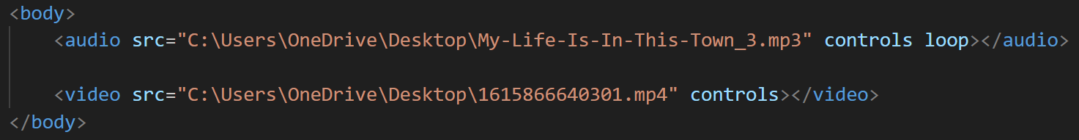VIDEO = With <video> tag we are embed video in a webpage or HTML documents (<video> </video>).

**Attributes:**

* Src: Specifies the URL or path to the audio or video file.
* Controls: Adds default playback controls (play/pause, volume, etc.) to the audio or video player.
* Loop: Specifies that the audio or video should start over again from the beginning after it has ended.
* Muted: Specifies that the audio should be muted by default.
* Width: For change the width of the video player.
* Height: For change the height of the video player.

**Q. Semantic element in HTML5?**

ANS = A semantic element gives the browser and the developer a clear explanation of what it means. The explanation that elements like <header>, <footer>, and <article> are viewed as semantic is that they clearly indicate the function of the element and the type of information that it contains.

List of new semantic elements

* <article> / <aside> / <details> / <summary> / <figcaption> / <figure>
* <header> / <main> / <footer>
* <mark> / <nav> / <section> / <time>

These semantic elements help structure the content in a meaningful way, making it more accessible, searchable, and understandable for both humans and machines. By using these tags appropriately, you can enhance the semantic structure of your web pages and improve their overall quality.

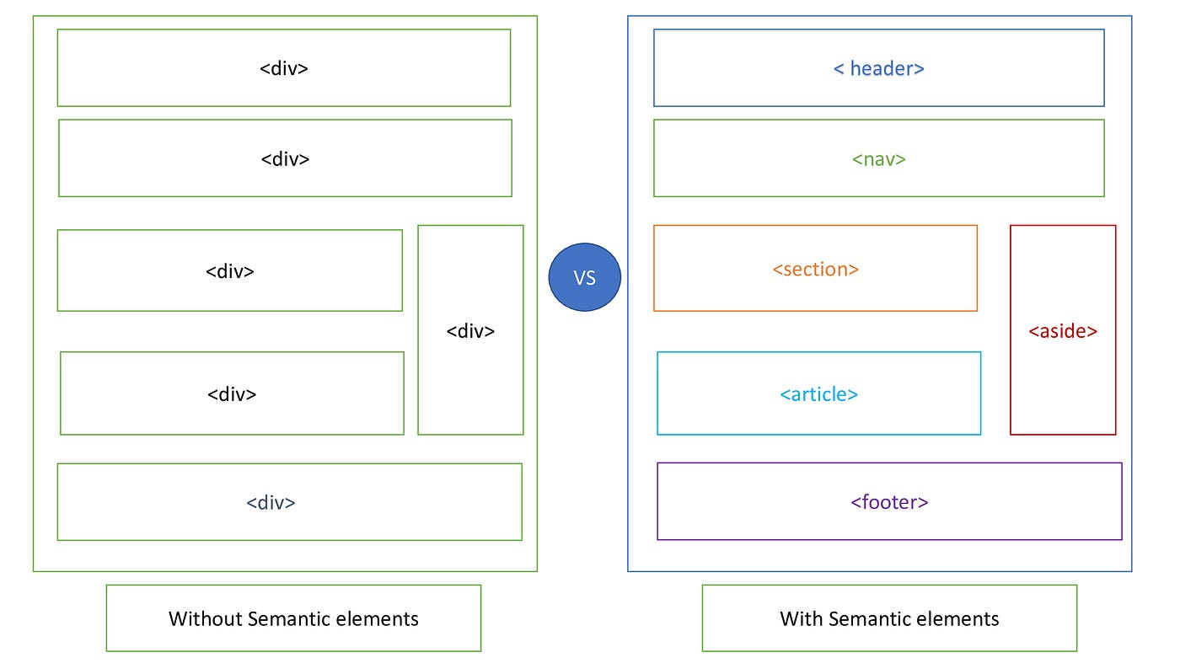<div> elements behave similarly to <header>, <nav>, <section>, <article>, <aside>, and <footer> elements. They organize other components into parts of the page. On the other hand, since a <div> tag may hold any kind of content, it is simple to determine what kind of content belongs in a semantic <header> area.

**Q. Canvas and SVG tags**

ANS = **SVG** is a Scalable Vector Graphics. It’s used to define graphics for the Web and vector-based graphics in XML format. SVG graphics are contained within the <svg> element of HTML. SVG stands for defining visuals like boxes, circles, text, etc., SVG is helpful. SVG is a language used to describe graphical applications and 2D visuals in XML. SVG can be modified through script and CSS.

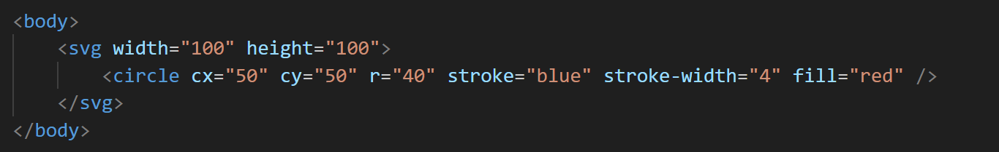Example: INPUT



OUTPUT =

**Canvas**: Scripting, generally JavaScript, is used to draw visuals on the fly using the HTML element. The element is nothing more than a graphic container. The visuals are really drawn using a script. There are several ways to create pathways, boxes, circles, text, and pictures on canvas. Canvas can be modified through script only.

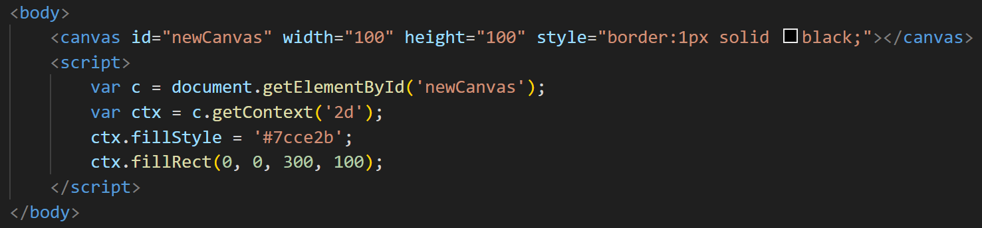Example: INPUT

OUTPUT =